Music in the
Cathedral
presents
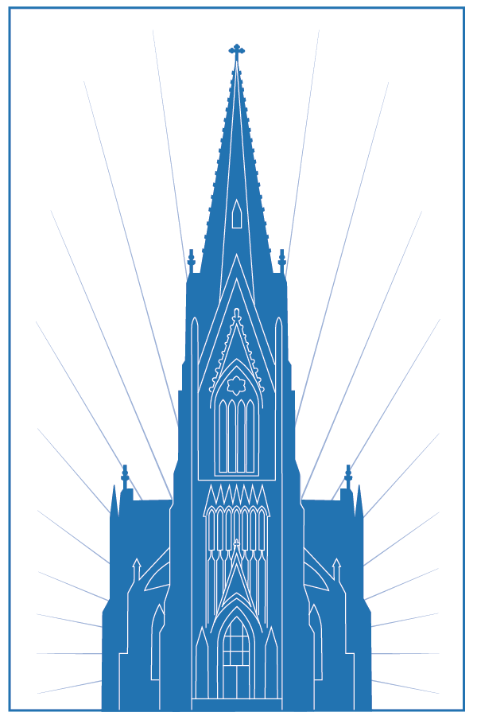
Steinway Recital
Program
Veselin Ninov, piano,
with the
New York Virtuosos

Sunday, 16 March 2025 at 4:00 PM
Cathedral of the Incarnation
Garden City, New York

This program is dedicated to the 225th anniversary of Beethoven’s birth
Ludwig Van Beethoveen was born in 1770 in Bonn, Germany as the son of a court musician. His talent for the piano was soon realized and he gave his first public performance at the age of seven. Young Beethoven was employed as a court musician in Bonn from 1787. During this time he studied briefly under both Haydn and Mozart. In 1792, he relocated to Vienna. This is the beginning of his early period which lasted roughly until 1800. During this time Beethoven quickly made a name for himself as a virtuoso pianist. His compositions during this period consisted mainly of works for his main instrument, such as the First Piano Concerto, Op.15 (1798). Beethoven's hearing was also beginning to deteriorate at this point, however, he went to great lengths to hide this fact from those around him.
Beethoven is a transition figure in the history of western music. He is generally known as the father of the Romantic era. However, during the first period most of his compositions were classical (ie Hadyn and Mozart) in nature. However, in 1800 Beethoven is reported to have turned to his friend Krumpholz and said, "I am not very well satisfied with the work I have thus far done. From this day on I shall take a new way." And basically, he did. Beethoven abandoned the classical forms of the previous century and set out for a more expressive (Romantic) musical voice. His musical imagination began to grow beyond that of the piano. This period, which later became known as the Heroic Period because of the larger than life nature that his compositions took on, saw the creations of such masterpieces as the Tempest Sonata, Op. 31 (1801-2), the 3rd Symphony (Eroica), Op. 55 (1803), his only opera, Fidelio, Op. 72 (1803-5), and the 5th Piano Concerto (Emperor), Op. 73 (1809). Some say that this middle period was Beethoven's greatest. It certainly was his most productive. In about a decade Beethoven produced countless masterpieces in every genre.
In 1809, however, his musical output began to drop, possibly in connection to his declining health and mental state. The late period saw the compositions of Beethoven's largest works: the Mass in D (Missa Solemnis), Op. 123 (1818-23), the 9th Symphony (Choral), Op. 125 (1818-23), the Hammerklavier Sonata, Op. 106 (1818), and the late string quartets.

PROGRAM

PIANO CONCERTO NO.1, OP.15 IN C MAJOR
I. Allegro con brio
II. Largo
III. Rondo. Allegro scherzando
Intermission
PIANO CONCERTO NO.5, OP.73 IN E-FLAT MAJOR "EMPEROR"
I. Allegro
II. Adagio un poco mosso
III. Rondo: Allegro ma non troppo

The1931 Steinway, which serves the Cathedral music program,
has been fully restored in loving memory of Jean Perry with generous support from First National Bank of Long Island.

A very special thanks to Alexander Kostakis and A.C. Pianocraft Inc.,

of Long Island City, for their exemplary work in restoring this vintage instrument.

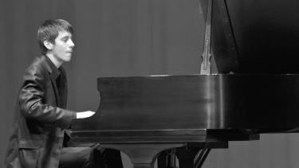
Bulgaria born pianist Veselin Ninov is the winner of numerous competitions in USA, Canada, Bulgaria, Russia, Sweden and Turkey. He has studied with the famous mentors Antoaneta Vodenicharova from Bulgaria and Dr. Tamara Poddubnaya from Russia and the USA. His prizes include Grand Prix at the LISMA International Competition in New York, 1st prize at the Stockholm International Competition, 1st prize at the International Competition ‘Way to Mastery’ in Rostov on Don, 1st prize at the ‘Classical Virtuosos of Tomorrow’ Competition in Pennsylvania and Grand Prix at the Darrell International Competition in New Hampshire. Mr. Ninov has been a soloist of orchestras, judging international festivals and competitions and has given master classes and solo and chamber music recitals in Merkin Hall, Lincoln Center, Carnegie Hall, Kimmel Center, Steinway Hall and others. His performances have been broadcasted on the BNR Radio and the Bulgarian National Television. Since 2013 he is represented by BV Artists International in New York.

MUZIKA FOUNDATION - NEW YORK

a non-profit organization

Mission:
To help and nurture young talent to reach the next step in their professional development and to recognize musical mastery.
To promote the performance of repertoire by the greatest Bulgarian composers and to promote Bulgarian Music in general.
To sponsor and create musical opportunities for classical musicians of any nationality.
Scholarship and Awards: As a non-profit organization all donations to MUZIKA FOUNDATION go directly to a scholarships and awards fund to support the highest caliber musicians on their path to achievements and a professional carrier.
For more information, see their website, at www.manolovcompetitionny.com.

To donate to help support the vital work of The Muzika Foundation,
can this code:





Frank and Camille's Pianos is a proud partner of the
Muzika Foundation for the Future"
~Upcoming musical events at the Cathedral~

Choral Evensong for Lent – Sunday, April 6th at 4:00
Choral Evensong is sung daily in cathedrals in the UK. This service follows the traditional model, with music sung mostly by the Cathedral Choir. This service will feature mostly early works, including the Short Service of Orlando Gibbons, and anthems by Henry Purcell. Join us for this peaceful beginning to the week.

HOLY WEEK & EASTER at the CATHEDRAL
The Cathedral Choirs spend considerable effort on enriching the many Liturgies of Holy Week with glorious choral music. We invite you to join us for the following services, all unique to the day, sung by our Cathedral Choirs.

The Office of Tenebrae – Wednesday, April 16th at 7:30 pm
Tenebrae, a favorite of the Cathedral community, sees the gradual extinguishing of candles and other lights in the church until only a single candle, considered a symbol of our Lord, remains. Music for this service will be sung by the upper voices of the Choir, including works by Pergolesi, Hurd, Sumsion and Robinson.

Solemn Mass for Maundy Thursday – Thursday, April 17th at 7:30 pm
This Mass commemorates the Institution of the Holy Eucharist, and includes the Washing of Feet, recreating the action of the Lord the night before his Crucifixion. Choral music will include works of Duruflé, di Lasso, and Near.

Solemn Liturgy of Good Friday – Friday, April 18th at 12:00 noon
This Liturgy, unique to the day, commemorates the Passion and Death of the Lord. Choral music will include the Passion of Saint John by Victoria.

The Great Vigil of Easter – Saturday, April 19th at 7:30 pm
This Liturgy, the first Mass of Easter, begins the celebration of the Resurrection.

Solemn Mass for Easter Day - Sunday, April 20th at 11:15 am
Music at the 11:15 Choral Mass will be sung by the Cathedral Choirs and will include the Missa Festiva by Flor Peeters and the anthem Surrexit Christus hodie by Charles Marie Widor.

Our annual Music in the Cathedral brochure is available at the entrances to the Cathedral. If you do not currently receive our mailings, please add your name and address to the list at the entrance to the Cathedral. You can also receive email notices of future musical events at the here by sending us your email address to music@incarnationgc.org. You are always welcome here!

